To Install Litemanager pro

Step 1- Go to [www.litemanager.com](http://www.litemanager.com) and downlowd file on Windows operating system.

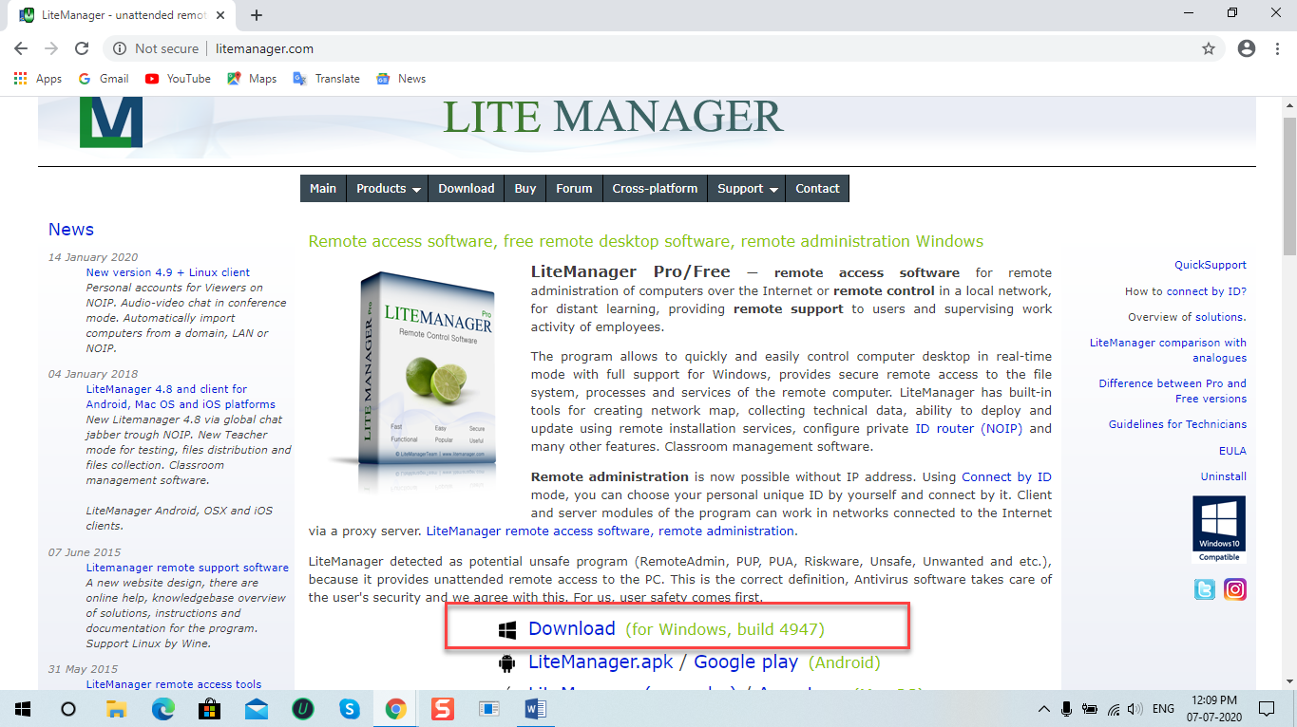

Step 2- Open file once download is completed.

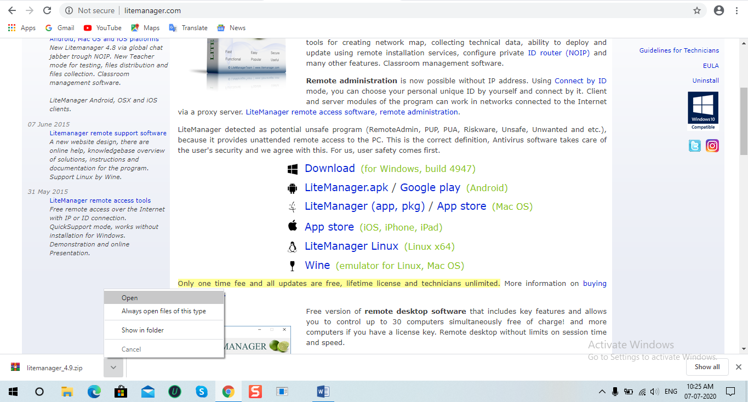

Step 3- Open LiteManager Pro - Server.msi file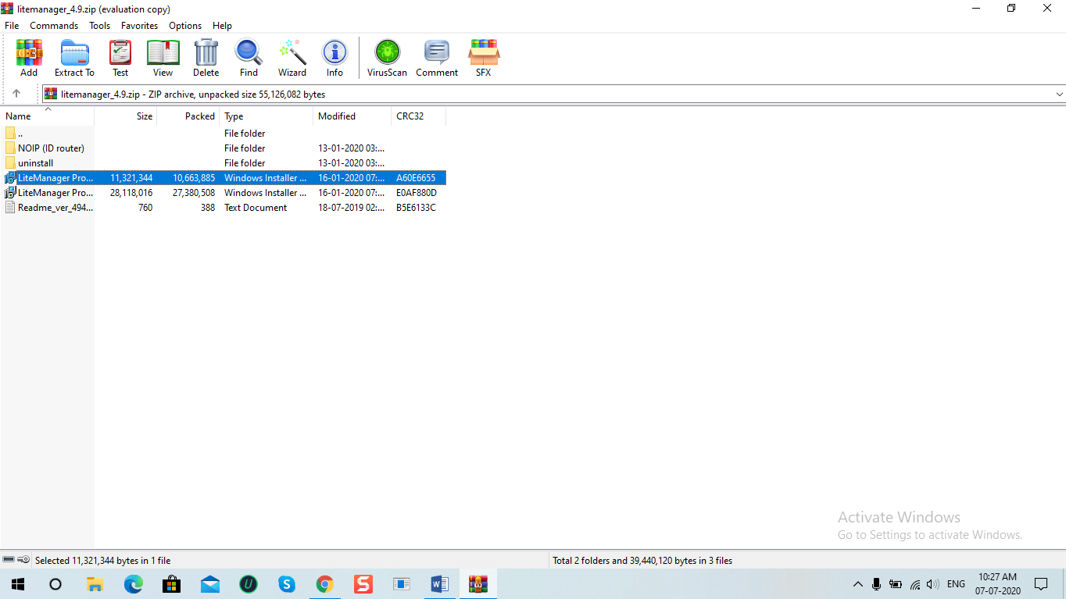

Step 4- Follow installation procedure

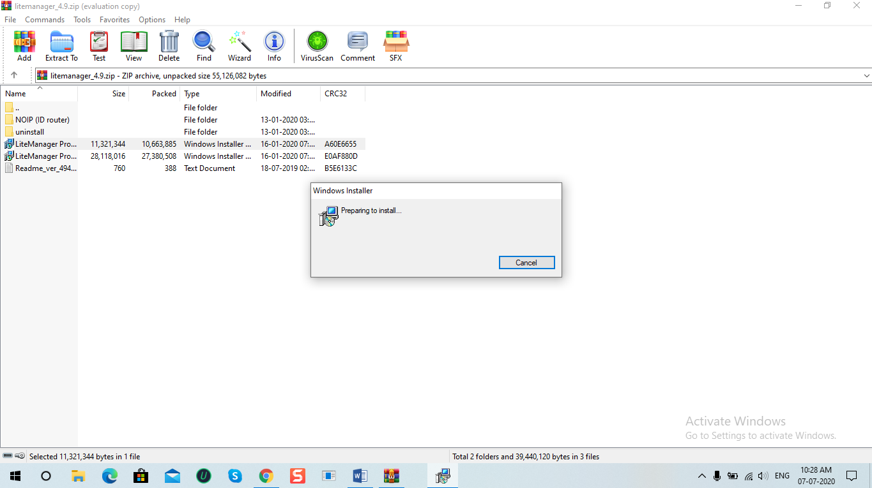

Step 5- 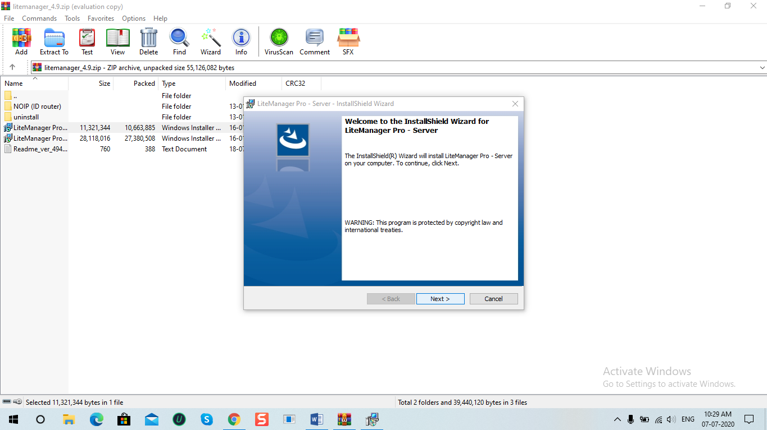

Step 6- Accept the terms and Click on next.

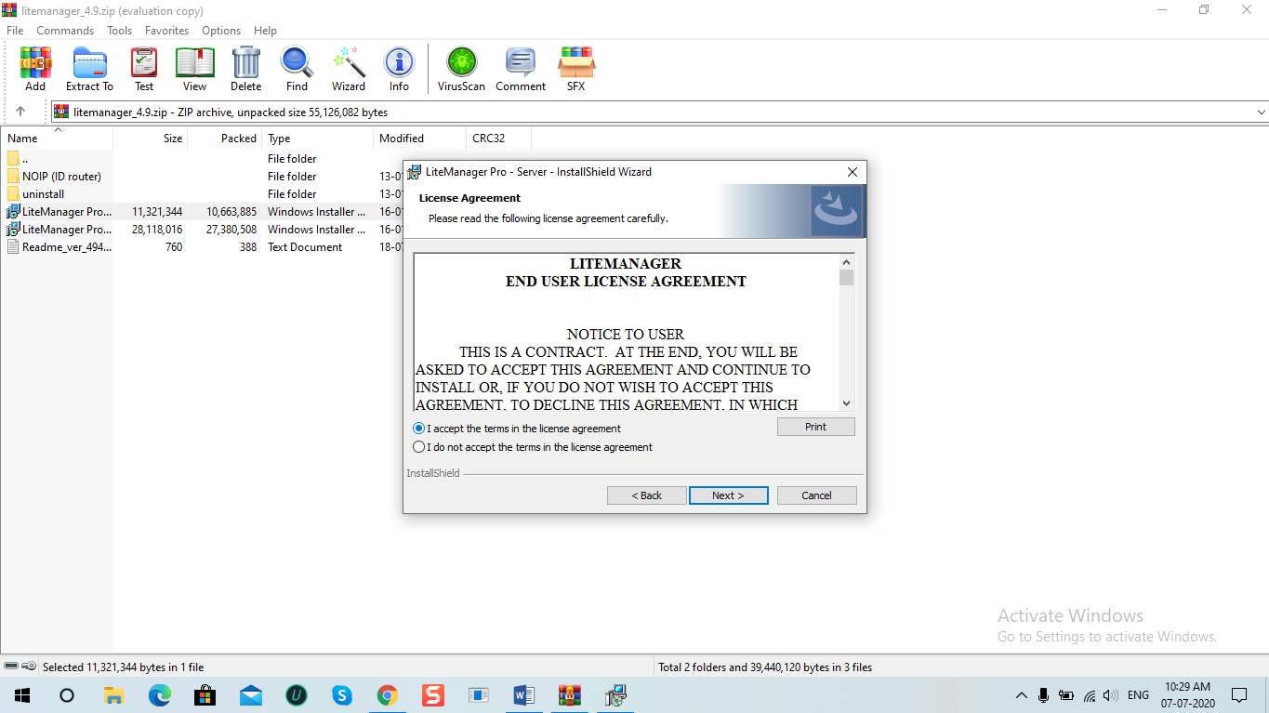

Step 7-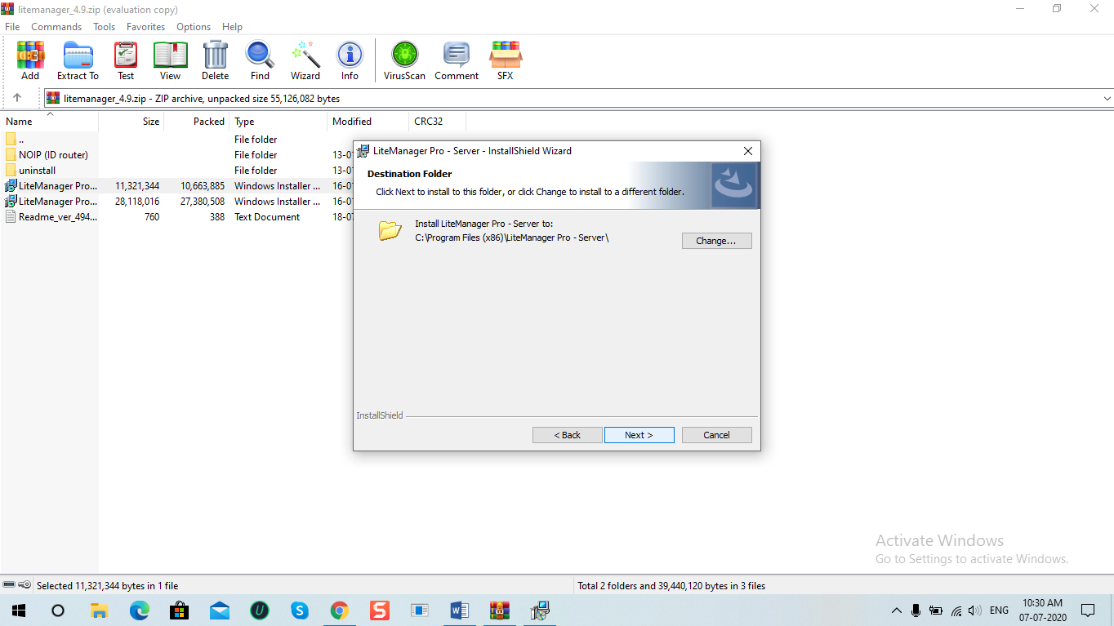

Step 8-

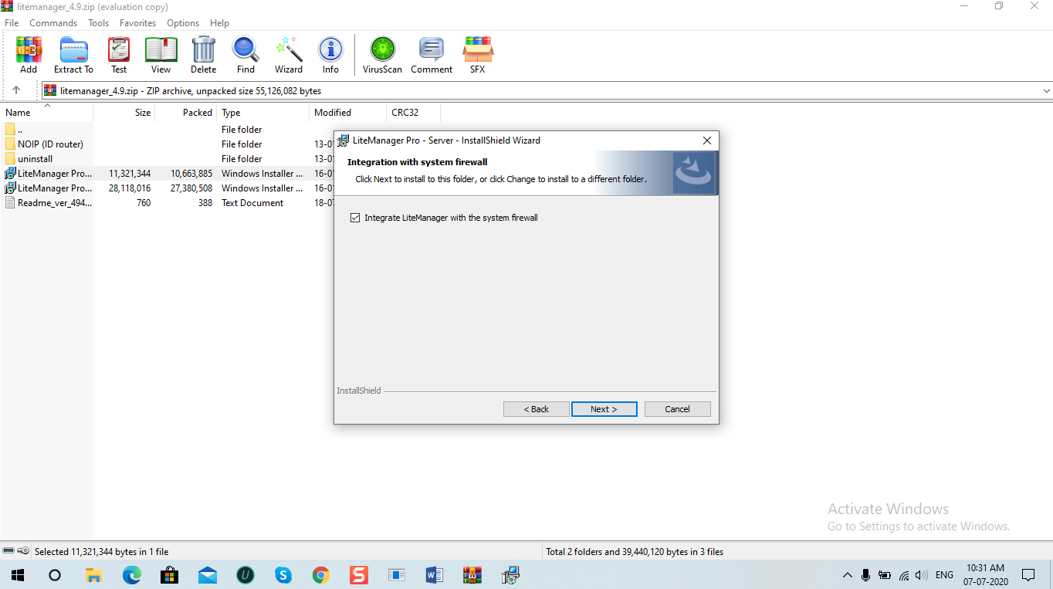

Step 9-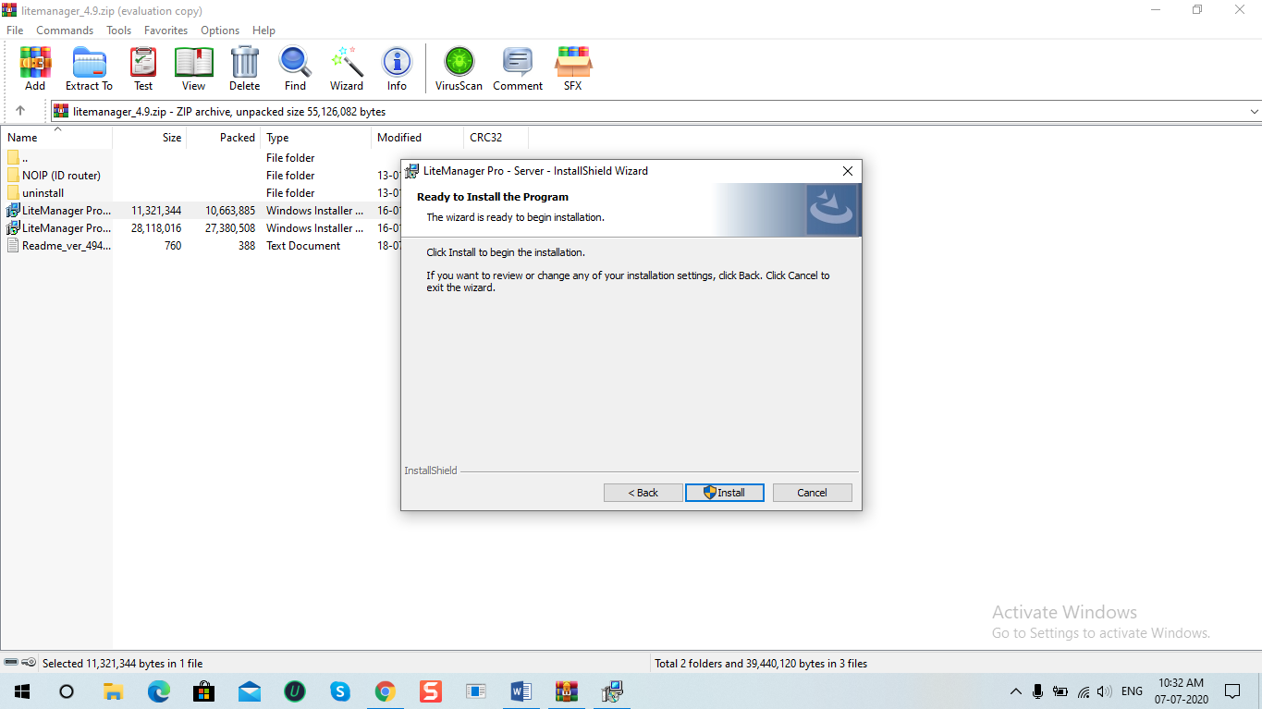

Step 10-

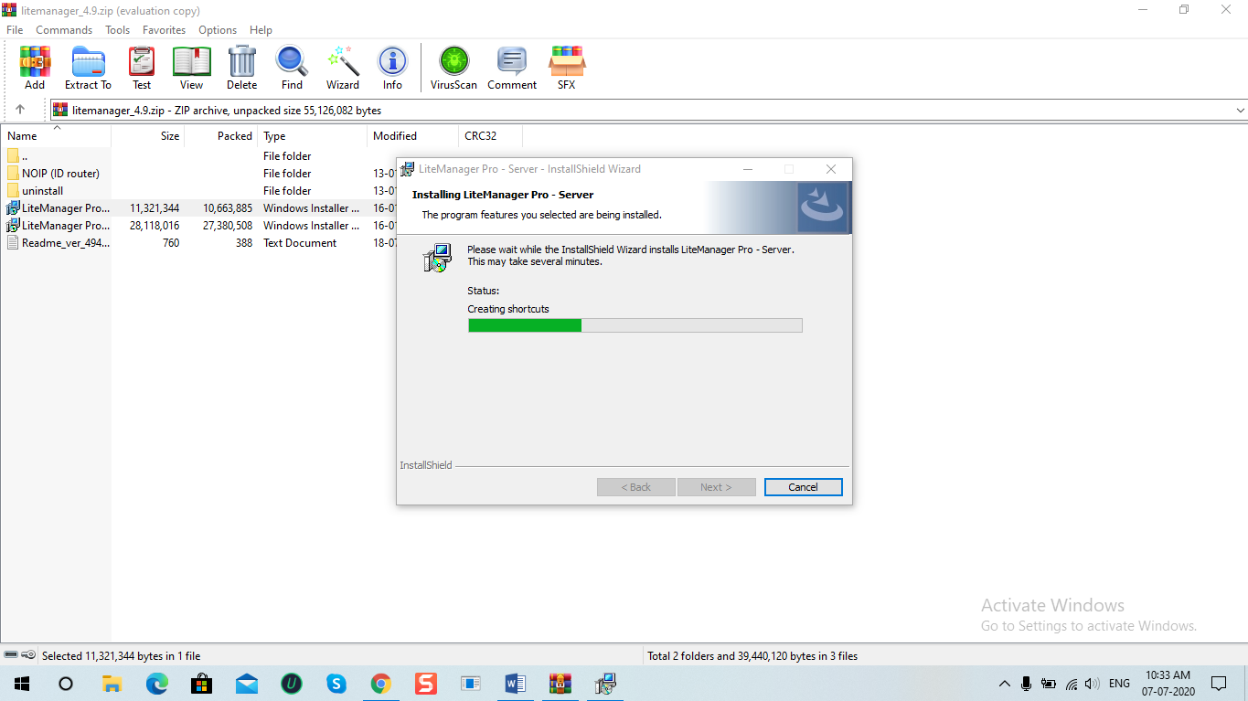

Step 11-

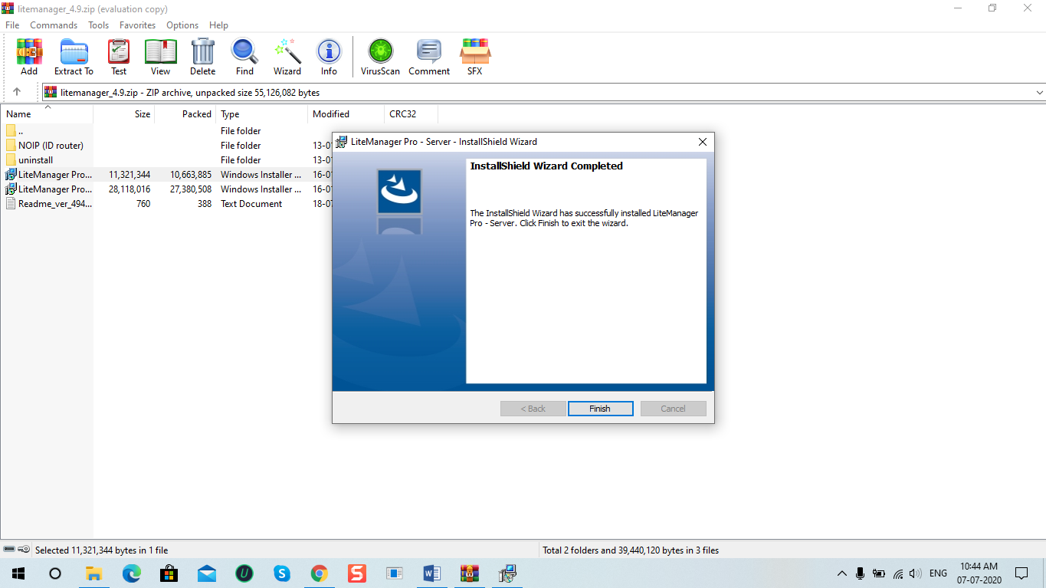

Step 12-

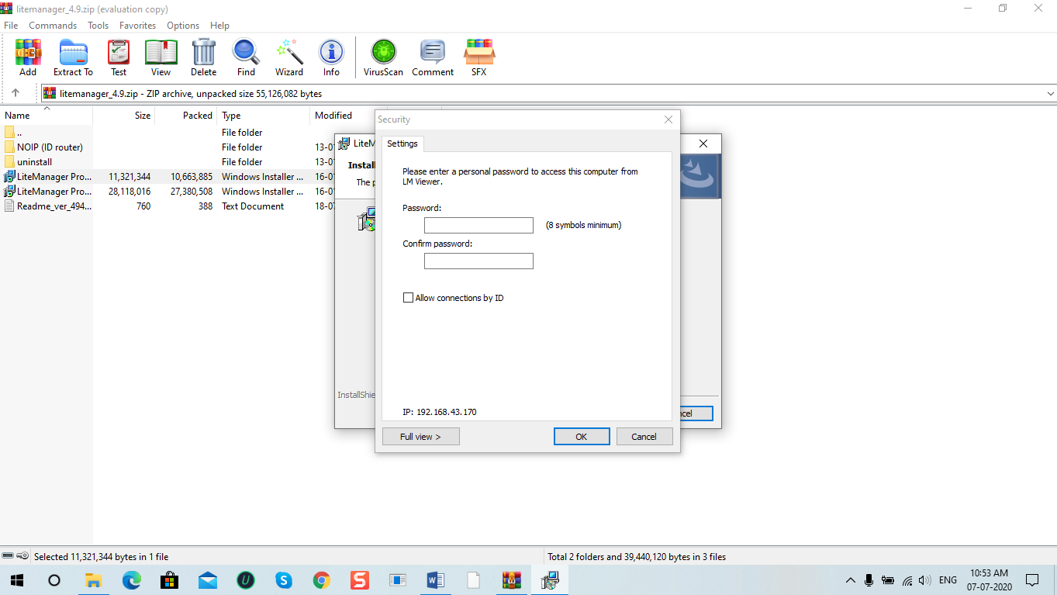

Step 13-

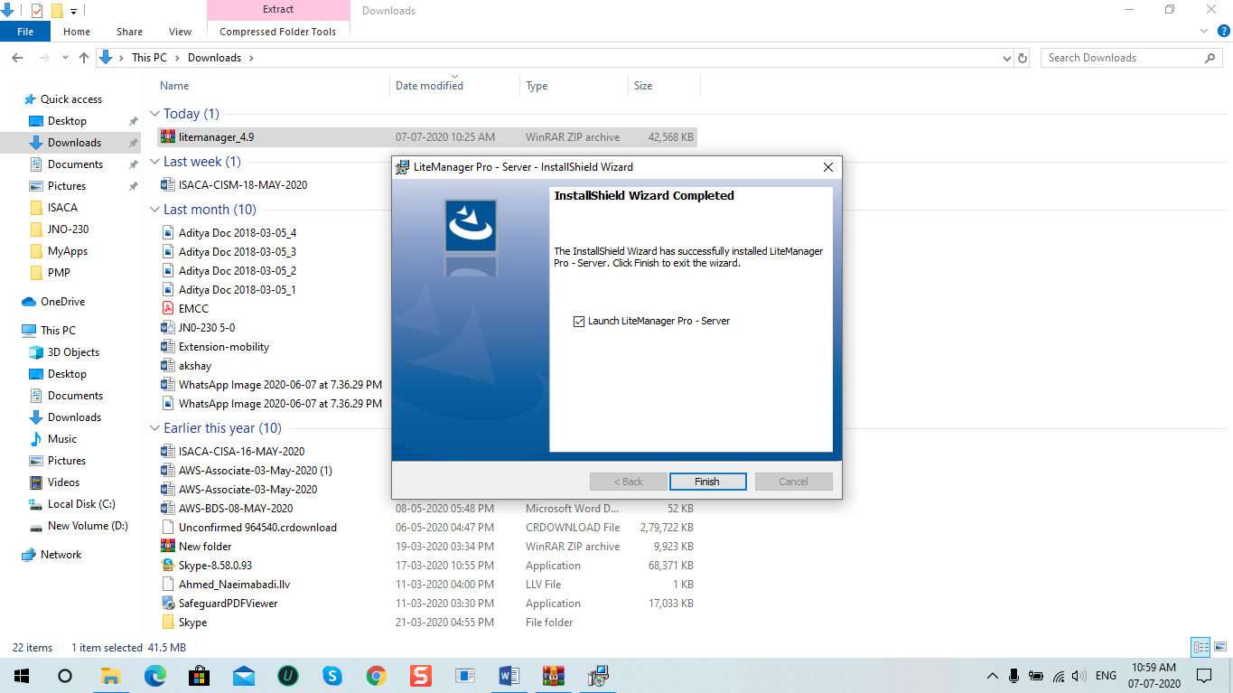

Step 14-



Step 15- Right Click on litemanager and click on connect by ID.

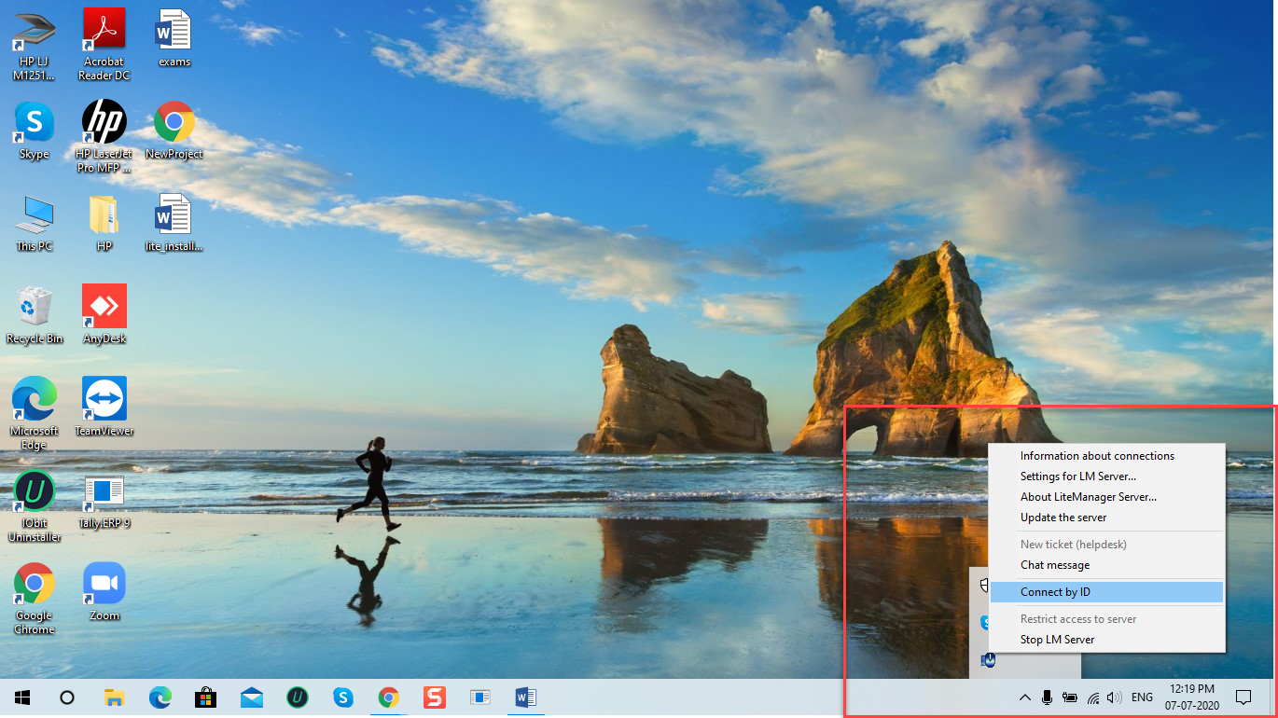

Step 16- Click on connect and your ID should be in green colour. Now you are connected.

